|  |  |
| --- | --- |
| documentation  This is a project for world’s Global Tech face-off. |  |

HEALTH PLUS

TEAM MEMBERS

|  |  |
| --- | --- |
| STUDENT 1323558 | SHAYAN AHMED BAIG |
| STUDENT 1328216 | SYED AMAAN ALI |
| STUDENT 1322685 | MIRZASHAN |
| STUDENT 1322010 | RUMAAN UL HAQ SIDDQUI |
| STUDENT 1328227 | MUHAMMAD AHRAS |

PROJECT MENTOR: MISS ANNY JIBRAN

Contents

INTRODUCTION: 6

PROBLEM DEFINITION 7

CASE STUDY 7

SYPNOSIS 8

HARDWARE & SOFTWARE REQUIREMENT 8

SCOPE OF THE WORK 9

ARCHITECTURE AND DESIGN OF THE SYSTEM 10

SITEMAP 11

TASK SHEET 12

LIST OF VALIDATION 13

SUBMISSION CHECKLIST 14

SCREEN SHOTS 16

# Introduction:

The thirst for learning, upgrading technical skills and applying the concepts in real life environment at a fast pace is what the industry demands from IT professionals today. However busy work schedules, far-flung locations, unavailability of convenient time-slots pose as major barriers when it comes to applying the concepts into realism. And hence the need to look out for alternative means of implementation in the form of laddered approach.

The above truly pose as constraints especially for our students too! With their busy schedules, it is indeed difficult for our students to keep up with the genuine and constant need for integrated application which can be seen live especially so in the field of IT education where technology can change on the spur of a moment. *Well, technology does come to our rescue at such times!!*

Keeping the above in mind and in tune with our constant endeavour to use Technology in our training model, we at Aptech have thought of revolutionizing the way our students learn and implement the concepts using tools themselves by providing a *live and synchronous TECHWIZ learning environment!*

# PROBLEM DEFINITION

You will design and build a website named 'Health Plus’s which will allow users to view appointment details, information regarding their personal health vitals such as BP, Glucose, and so on, view medicine dosage details, and more.

# CASE STUDY

Health is one of the most important factors in today’s era and should be our first priority. With the increase in sickness and large numbers of urban population, it becomes difficult to book appointments or visit a doctor. There may be scenarios where a person wants to check his/her Blood Pressure (BP), Weight, and so on, and for this purpose, they require to keep visiting clinics. Sometimes, even after an appointment is booked, a person may forget about this or may reach at the hospital/doctor’s clinic and discover that the doctor is not available. What individuals seek is an easy means to help them monitor and track their health. They should be able to view doctor appointments, medicine dosage schedules, and track their weight, BP, and glucose levels, and more.

# sypnosis

You will design and build a Website named 'HealthPlus' which will allow users to

view appointment details, information regarding their personal health vitals such

as BP, Glucose, and so on, view medicine

dosage details, and more.

# hardware & software requirement

# Hardware

* Intel Core i5 Processor or higher
* 8 GB RAM or above
* Color SVGA 500 GB Hard Disk space
* Mouse
* Keyboard

# SOFTWARE USED

# Software

Technologies to be used:

1. Frontend: HTML5, CSS3, Bootstrap, JavaScript, jQuery, AngularJS, and XML

2. Data Store: JSON files or TXT files

* Visual Studio Code

# scope of the work

Depending on the decision taken by the management regarding the health plus, following are the requirements based on which the website must be developed.

1. The portal will be designed as a Single-Page-Application and responsive Website with a set of pages and menus that represent choice of activities to be performed. The pages, menus, and other visual elements must be designed in a visually appealing manner with attractive fonts, colors, and animations. All of these should also be laid out in a responsive manner.
2. **Home Page:** It will display menus such as home, About Us, medicine, payment, appointment, Contact Us, and so on. A few featured products displayed with images and captions will be displayed on the home page. The home page should accept first name from the user and display a personalized welcome message. At the top corner, the user's first name should be displayed for the entire duration that the portal is loaded.
3. **Payment :** This option will showcase the products one can order online via health plus. Products can be displayed through an image gallery and can have product information such as availability, stock, price, discount (if any), product description, and so on.
4. **medicine:** Using this option, users can search for a specific product that they are looking out for/of their interest.
5. **Appoinment:** This should show the shopping cart contents and total bill based on product price and quantity of products purchased. You need not implement payment functionality; just list the cart contents and compute the bill.
6. **About Us and Contact Us:** This menu option should display Email id, address, and contact number of the organization who is developing the system. This acts like the Customer Care service, which is available 24/7 to the users in case of any query.

# architecture and design of the system

# sitemap

HEALTH PLUS

HOME

MEDICINE

APPOINTMENT

ABOUT US

CONTACT US

APPOINMENT FORM

PAYMENT PAGE

# TASK SHEET

|  |  |  |  |  |
| --- | --- | --- | --- | --- |
| *s.no* | *task* | *Actual start day* | *When completed* | *status* |
| 01. | Case study | 11-AUGUST-2202 | 12-AUGUST-2202 | COMPLETE |
| 02. | Material searching | 11-AUGUST-2202 | 12-AUGUST-2202 | COMPLETE |
| 03. | Graphics  designing | 11-AUGUST-2202 | 13-AUGUST-2202 | COMPLETE |
| 04. | development | 13-AUGUST-2202 |  | COMPLETE |
| 05. | testing | 13-AUGUST-2202 |  | COMPLETE |
| 06. | documentation | 13-AUGUST-2202 |  | COMPLETE |

# LIST OF VALIDATION

Some sample validation as follows:

|  |  |
| --- | --- |
| OPTION | VALIDATED |
| Do all text links to the appropriate web pages? | YES |
| Do all images links to the appropriate web pages? | YES |
| Are all the images and links clearly visible on the page? | YES |
| Is the web page opening properly in all the tested web browsers? | YES |
| Are the animations loading well? | YES |
| Is the web page taking too long to load? | YES |
| Is the navigation sequences correct through all the web pages on the site? | YES |
| Is the web page responsive? | YES |
| Is the JavaScript coding working as expected in all click events? | YES |

# submission checklist

|  |  |  |  |  |
| --- | --- | --- | --- | --- |
| *s.no* | *List of items* | *yes* | *no* | *comments* |
| 1 | Are all users able to view images and links? | YES |  |  |
| 2 | Have all composites of the website been integrated and do they load as expected? | YES |  |  |
| 3 | Are the GUI content devoid of spelling mistake? | YES |  |  |
| 4 | Is the portal user friendly? | YES |  |  |
| 5 | Is the website launching correctly in the browser? | YES |  |  |

# Screen shots

HOME PAGE

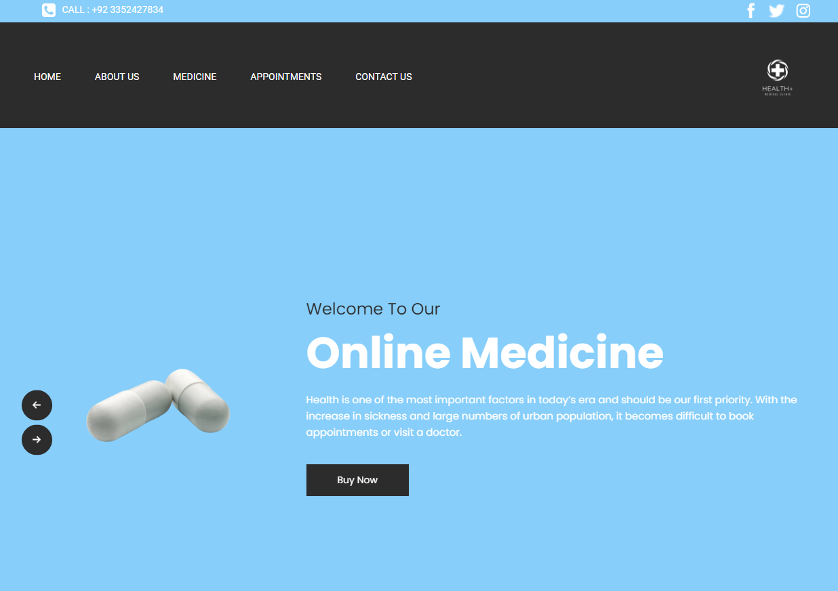

ABOUT US PAGE

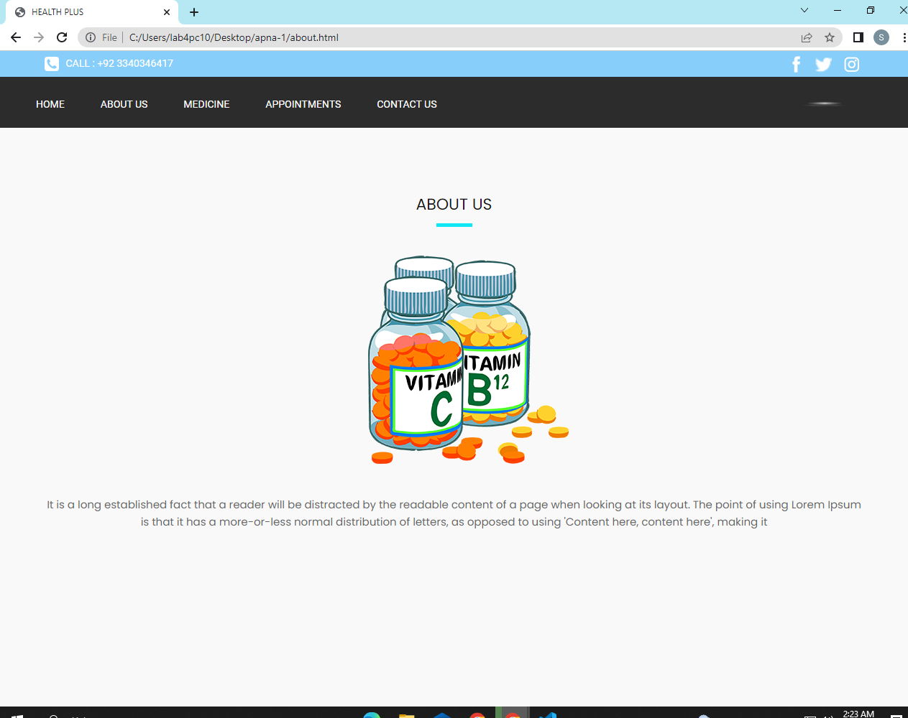

ABOUT US PAGE

MEDICINES PAGE

PAGE

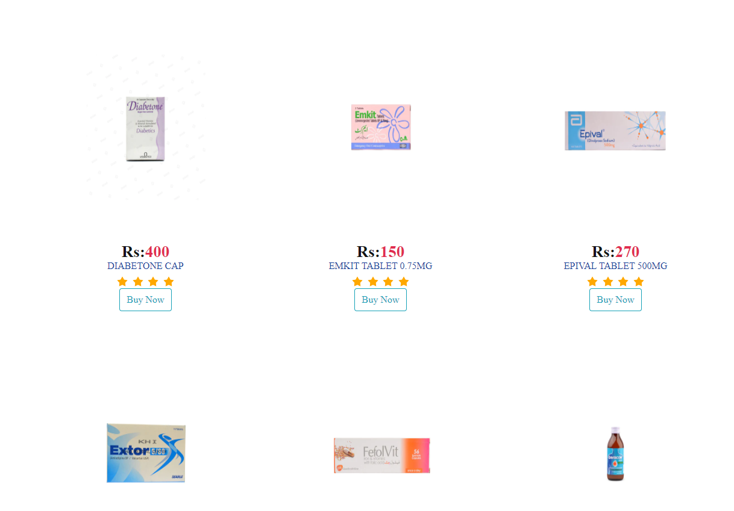

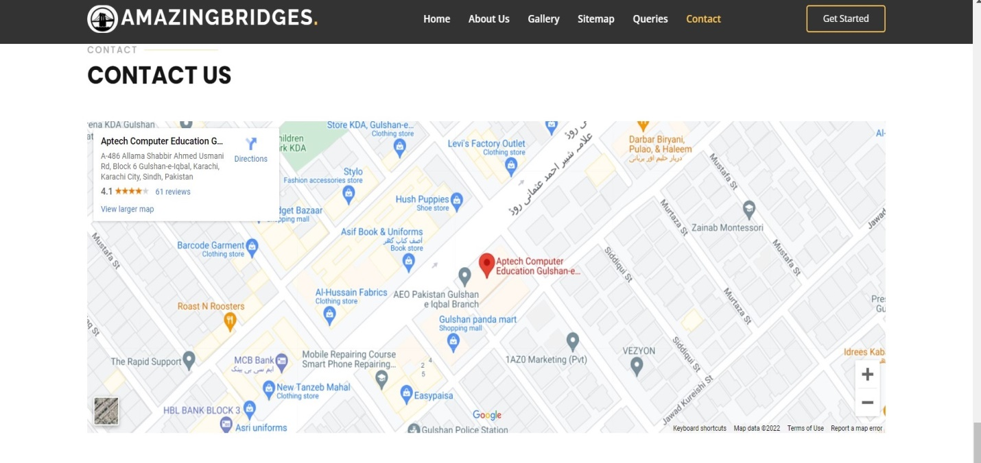

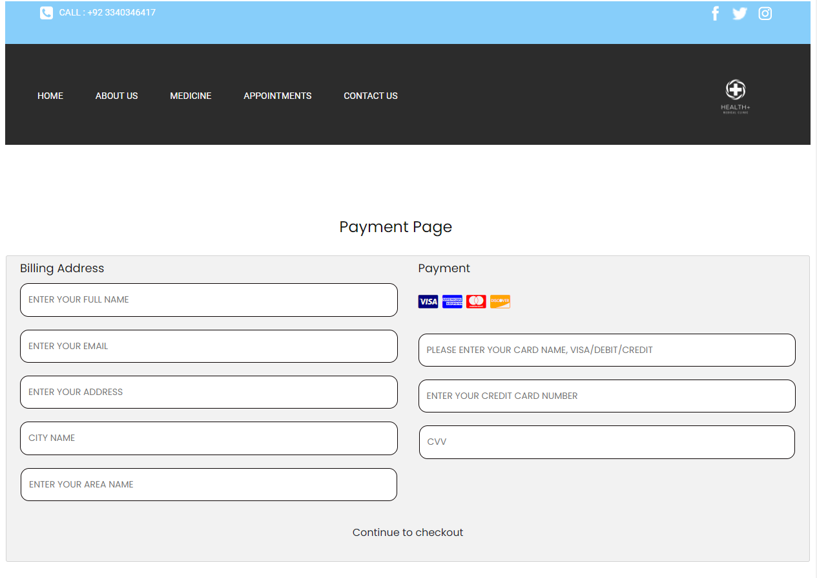

PAYMENT PAGE

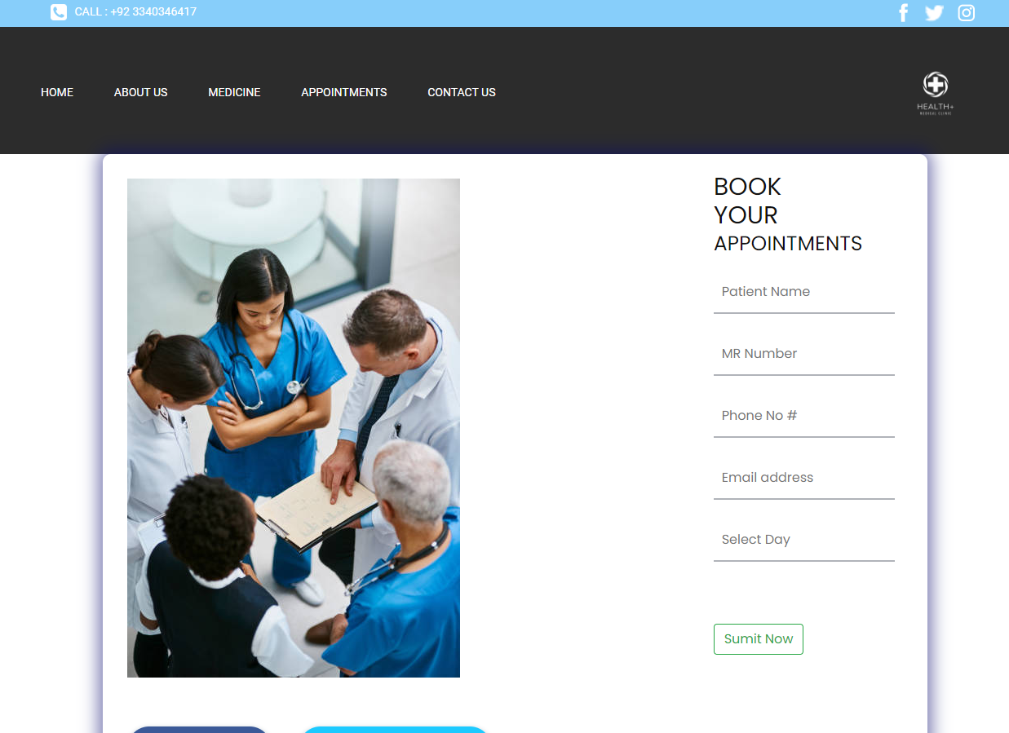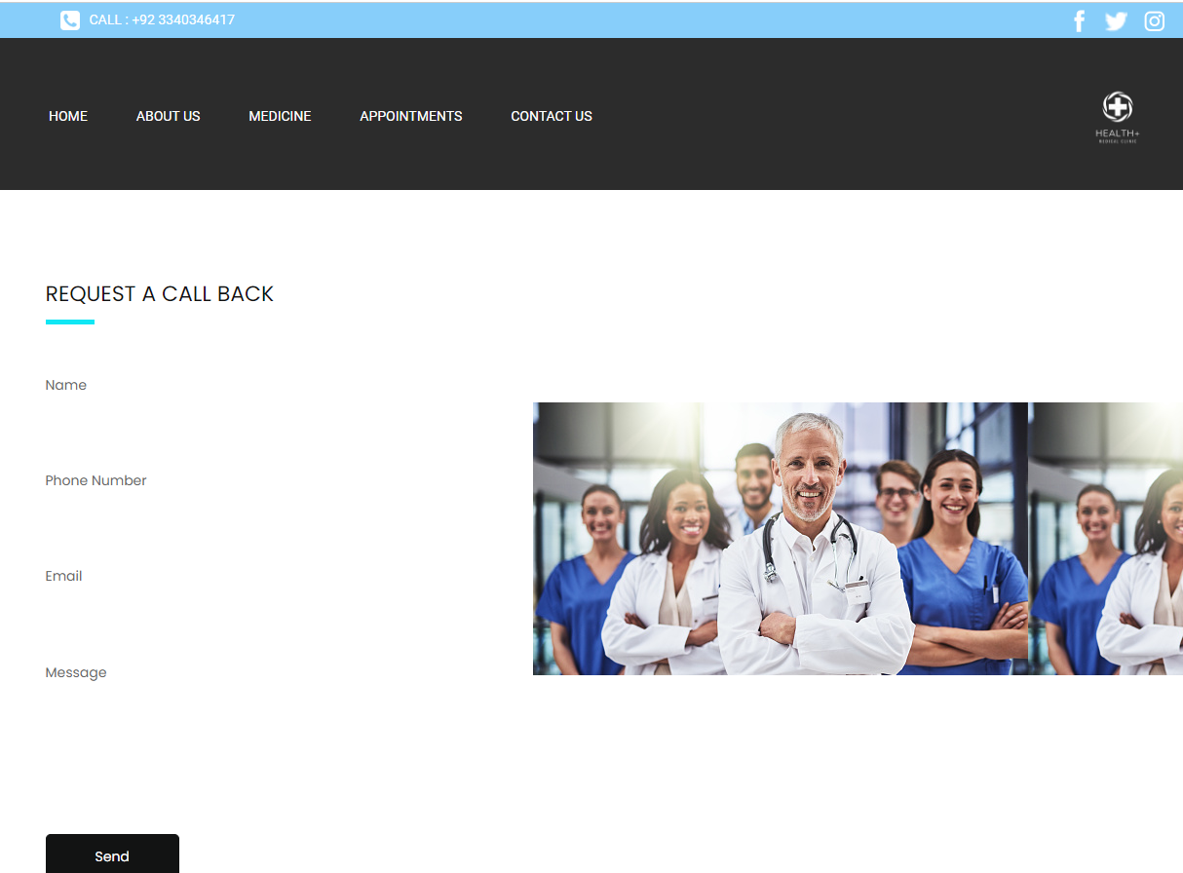

APPOINTMENT FORM PAGE

CONTACT PAGE